- Development is the sequence of age-related changes that occur as a person progresses from conception to death. The process includes both the biological and behavioral changes that take place as people grow older.

- Erikson's Theory of Psychosocial Development
- People evolve through 8 stages over life span
- Each stage is marked by a psychosocial conflict that involves confronting a fundamental question.
- Personality is shaped by how individuals deal with the psychosocial conflicts involving transitions in important relationships.
- Challenges in social relations stimulate personality development throughout life.

- Stages:
- 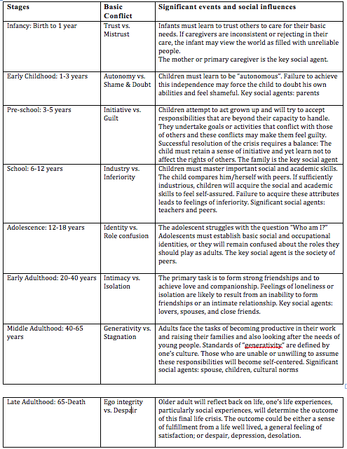

- Piaget’s Stage Theory

- - Assimilation: Interpreting new experiences in terms of existing mental structures without changing them.
- - Accommodation: Changing mental structures in response to new experiences.
- 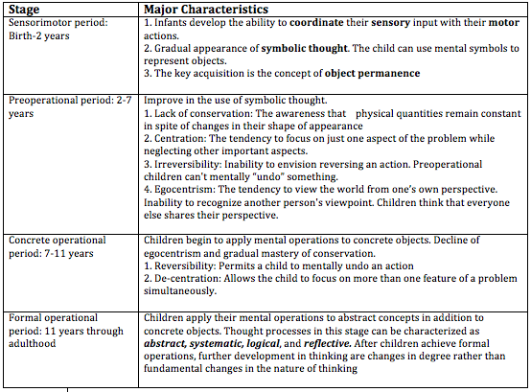

- Criticisms of Piaget’s theory
- 1. The timetable that children follow in passing through these stages varies across cultures.
- 2. Piaget underestimated the influence of cultural factors on cognitive development.

- Vygotsky’s Sociocultural theory
- - Human development occurs in a particular socio-cultural context that influences the form that it takes. Culture exerts great influence over how cognitive growth unfolds.
- - Children acquire their cognitive skills through dialog with others, their cognitive development is fuelled by social interactions with others who can provide guidance.
- -The zone of Proximal development: The distance between the level of development when independently problem solving and level of potential development determined by working under or with adult/peer guidance.

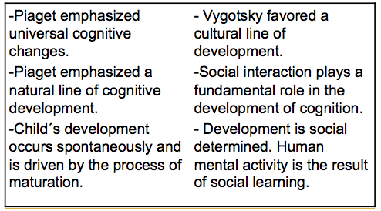
- Differences Btwn Piaget and Vygotsky

- Kohlberg’s Stages of Moral Development theory

