Chapter 12

Wheel of Loyalty
- Find solid foundation for customer loyalty
  - Right market segment
  - Right customers
  - Tier services
  - Deliver high level satisfaction
- Build loyalty
  - Develop close bonds with customers
  - Cross sell/bundle
  - Loyalty rewards, high level bonds

Loyalty levels
- Platinum
  - Rare
  - High profits
  - Not price sensitive
  - High service
- Gold
  - More than plat, less than iron
  - Above average Profit
  - More price sensitive
  - Mid service
- Iron
  - Main customer base
  - Average profit
  - Price sensitive
  - Regular service, no special treatment
- Lead (drag down firm)
  - Many
  - Loss in profit
  - Really price sensitive
  - Same service as iron

*Value not just volume
    - Customers looking for sales, are not beneficial
    - Churn easily
  - Customer satisfaction & Service Quality prereq. Loyalty
    - Highly satisfied/delighted customers are > likely to consolidate purchases
      - +word of mouth
      - Loyal advocate
      - May increase stock prices
    - Dissastisfied customers
      - Drives away customers
      - Churn

- Satisfaction
  - Defection
    - Low satisfaction level
    - Switch unless costs too high
    - Turn to "terrorists" (-WoM)
  - Indifference
    - Moderate satisfaction level
    - Will switch if better choice is available
  - Affection
    - Very high satisfaction levels
    - Praise firm in public
    - Don’t look for alt. providers
    - Leads to improved future business performance
- Strat for developing loyalty bonds
  - Deepening the relationship
    - Bundling and cross sell services
      - *Rogers: phone, internet, tv
      - *Bank: debit, credit, RRSP
    - Makes switching hassle for customer
    - More convenient and better value when same provider
  - Encouraging via financial and nonfinancial rewards
    - Financial rewards ( Hard benefits)
      - Loyalty programs
      - Discounts
      - Cash back
      - ** Can cause negative feelings
        - Dissatisfaction
        - Can’t redeem points
        - Troublesome / time consuming
    - Nonfinancial Rewards (Soft benefits)
      - Non-monetary benefits
      - Priority reservation/waitlist
      - Higher baggage allowance
      - Priority upgrading
      - Access to lounges
      - Recognition (Starbucks Gold)
      - Typically more powerful than financial
  - Social bonds
    - Personal relationship between provider and customer
    - Trust, good for loyalty
    - Better chance to keep
    - Hard for competitors to imitate
  - Customization bonds
  - Structural bonds

Reducing Defections
    - Analyze customer defections and monitor declining accounts
        - Address key churn driver
- Find and fix problem to reduce others
- React with retention specialists at call centers
      - Implement complaint handling and recovery procedures
i.
c. Increase switching costs
i. deters customers from wanting to switch
ii. created by having contractual penalties
** phone plans & upgrading

CRM: Customer Relationship management
        - Captures and delivers to various touchpoints
  - Person serving customer has easy access to customers account details
  - Past transactions, history of service, previous problems
Helps understand, segment, and tier customer base

Comprehensive CRM strategy include:
      - Strategy development
      - Value creation\
      - Multichannel integration
      - Information management
      - Performance assessment

Chapter 13

Customer Complaining Behaviour

Customer Response to service failure
- Complain to employee
- ask to speak to manager
- file a complaint
- choose another supplier next time
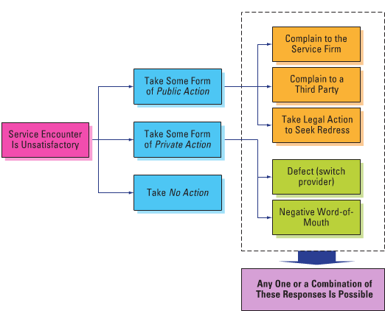

Why do customers complain?
- Obtain restitution or compensation
- Release their anger
- Help to improve service
- Out of concern for others

What proportion of unhappy customers complain?
- 5-10% complain, sometimes far lower often

Why don't unhappy customers complain?
- not want to take time to write letter, send email, fill form
- don’t see it important enough to be worth effort
- don’t believe that anything will be done
- don’t know what to do
- avoid stress of a confrontation

Who is most likely to complain?
- higher socioeconomic levels more likely to complain
- better education, higher income, greater social involvement gives confidents, motivation to speak up when encountering problems
- people that are more knowledgeable about the product

Where do customers complain?
- majority are @ place where service was received
- 99% was given face to face or over phone
- 1% were in emails, letters, customer feedback
- 3% unhappy complained to flight attendant, not headquarters

What do customers expect once they have made a complaint?

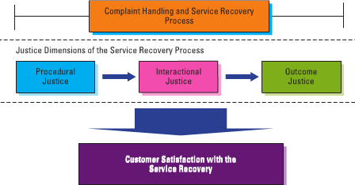

Procedural justice
- polices and rules customers go through to seek fairness

Interactional justice
- employees who provide service recovery
- give explanation for failure, try to solve problem
- must be seen as genuine, honest, and polite

Outcome justice
- compensation customer receives due to losses and inconvenience due to service failure
- compensation for time, effort, energy spent during process of service recovery

Customer responses to effective service recovery
- Impact of effective service recovery on customer loyalty
- complaints satisfactorily resolved, higher chance of remaining loyal
- 15x higher to recommend company
- 19% retention when company offered to listen
- 54% retention when complaint was solved
- 82% when problems fixed on spot

- Service recovery paradox
- phenomenon where customers feel more satisfied after excellent service recovery
- 2nd fail, SRP disappeared
- gives firms 2nd chance to redeem themselves
- better to do it right the first time.

Principles of effective service and recovery systems
- Make it easy for customers to give feedback
- special phone line for complaints
- links on website
- clearly display customer comment card in stores

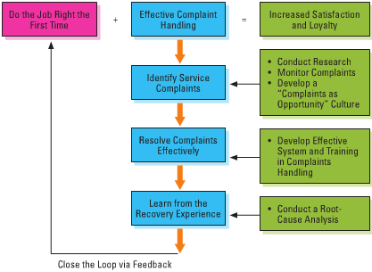

- Enable effective service recovery
  - Service recovery should be proactive
- ideally done on the spot
- service personnel should be sensitive to sign of dissatisfaction
- ask if customer is exp a problem
- Recovery procedures need to be planned
- backup plans developed for failures
- prepare scripts for CS rep in call centers
- Recovery skills must be taught
- provide effective training for sales cs rep
- RP with situations for routine and nonroutine failures
- Recovery requires empowered employees
- given freedom to use judgement to satisfy complaining customers
- need to be able to make decisions and spend money in order to resolve service problems
- need to be able to recover goodwill
- tweet back on company account to resolve problem

- How generous should compensation be?
  - What is the positioning of firm
- if known for excellent service, premium price for quality
- rare failure, major effort
- offer great value
- if known for typical mass market business
- apology and rework of service
- How severe was the service failure?
- let punishment fit crime
- minor inconvenience call for small compensation
- major damage will need more
- What is the affected customer?
- long term customers, worth effort to save business
- one time customers, demand less and contribute less to business,
- well dose of generosity
- one time customers may become repeat customer if treated well

- Dealing with complaining customers
  - Act fast
  - Acknowledge customer's feelings
  - Don’t argue
  - Show understanding of problem
  - Clarify truth
  - Give customers benefit of doubt
  - Propose steps needed to solve problem
  - Keep customers informed of progress
  - Consider compensation
  - Continue trying to regain customer goodwill
  - Self-check the system and improve it

- Service guarantees
  - The power of service guarantees
    - Forces firms to focus on what their customers want and expect
    - Sets clear standards
    - Require the development of systems for generating meaningful customer feedback
    - Force service organizations to understand why they fail and encourage them to identify and fix failure
    - Builds marketing muscle, reduces risk of purchase decisions, building long term loyalty

Situations where a guarantee may be inappropriate
- Companies that already have a strong rep for service excellence
- Best practice service firms will be expected to do whats right without offering a guarantee
- Firm who has poor service first has to work to improve quality
- Firm whose quality is uncontrollable cause of external forces like the weather
- When consumers see little financial, personal, or physiological risk associated with purchasing and using a service

- Discouraging abuse and opportunistic customer behaviour
  - Types of jay customers – acts in an abusive way, causing problems for the firm, its employees, and others
    - Cheat
      - Exploits service recovery policies and cheats on service guarantees
      - Fake returns become more common and socially accepted
    - Thief
      - No intention of paying
      - Sets out to steal goods and services
      - Bypass security/detection
    - Rule breaker
      - Too many rules make firm too inflexible
      - Fewer the rules, clearer important ones can be
    - Belligerent
      - Shouts, causes distraction
      - Abuses service personnel
      - Often takes bribes in order to shut up and stop badmouthing company
    - Family feuders
      - Argument with own family or others
    - Vandal
      - Physically abuses service facilities and equipment
      - Not necessarily customers, can be bored/drunk young people
    - Deadbeat
      - Delay payments
      - Sometimes happen due to short term problems with customer, can create better relationship over long term

- Dealing with consumer fraud
- maintain central data warehouse of all compensation payments, service recoveries, returned goods, and any other benefits given to customer based on special circumstances is needed.
- merge data across departments and channels for detecting unusual transactions and the systems that allow them
- ensure service recovery procedures are fair
- large firms should recognize more likely to cheat on them, acquire good fraud detection
- guarantees offered to regular customers/ part of membership program
- truly excellent services firms have less to worry about cheating than avg provider

Chapter 14

Improving service quality and productivity

Integrating service quality and productivity strategies

What is service quality?
- Dimensions of service quality
  - Tangibles (appearance)
  - Reliability (dependable)
  - Responsiveness (promptness and helpfulness)
  - Assurance (credibility, security, competence, courtesy)
  - Empathy ( easy access, good communications, customer understanding)

Identify and correcting service quality problems
- The gaps model in service design and delivery
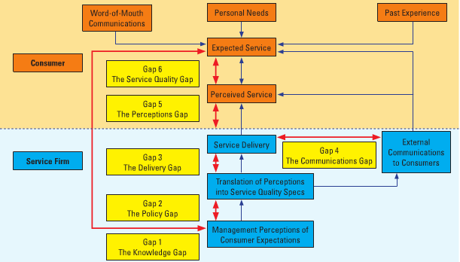
- Gap 1: Knowledge Gap: difference between senior management believe customers expect and what customers actually need/expect
- Gap 2: Policy Gap: difference between management understanding of customer's expectation and service standards
- Gap 3: Delivery Gap: difference between service standards and service delivery team's actual performance
- Gap 4: Communications gap: diff between company communicates and what the customer understands and experiences
- Gap 5: Perceptions Gap : diff between what is actually delivered and what customers feel they received
- Gap 6: Service Gap : diff between what customer expect to receive and perception of service that is delivered

Measuring and improving service quality
- without measurement, managers cannot be sure whether service quality gaps exist, let alone what type of gaps, where they exist, and what potential corrective actions should be taken.

Soft and hard service quality measures
- soft:
  - cannot be easily observed
  - Collected by talking with customers
  - Provides direction, guidance, feedback
  - SERVQUAL
    - Example of a complex soft measurement system
- Hard:
  - Counted, timed, measured through audits

Key Objectives of Effective Customer Feedback Systems – 3 categories
- Assessment and Benchmarking of Service Quality and Performance
  - Objective – how satisfied are our customers?
- Customer-Driven Learning and Improvements
  - Objective – what makes our customers happy or unhappy?
  - What are the strengths we want to cement, and what are the weaknesses we need to improve?
- Creating a Customer-Oriented Service Culture
  - Objective – concerned with focusing the organization on customer needs and satisfaction
- Of the 3 categories, firms do well in the first

Use a mix of customer feedback collection tools
- Total market, annual, transactional surveys
  - Measure satisfaction with all major customer service
  - High level of measurement, overall service satisfaction
  - Overall indicators don’t tell why customers are happy/unhappy
  - Transactional surveys, self explanatory
- Service feedback cards
  - Powerful, inexpensive
  - Feedback card, online popup form, email, sms
  - Easy to return
  - Mostly used by highly satisfied/ very dissatisfied, affects outcome
- Mystery Shopping
- Unsolicited Customer feedback
  - Not an overly reliable measure of overall satisfaction
- Focus Group discussions and service reviews
  - Specific insight
  - In depth 1-1 interview
  - Targets most valuable customers

Analysis, Reporting, and Dissemination of Customer Feedback
- Monthly Service performance update
  - Provies feedback on customer comments and operational process performance
- Quarterly service performance review
  - Provides them with trends in process performance and service quality
- Annual service performance report
  - Gives top management a representative assessment of the status and long-term trends relating to customer satisfaction

Tools to analyze and address problems
- Fishbone Diagram
  - Cause and effect analysis
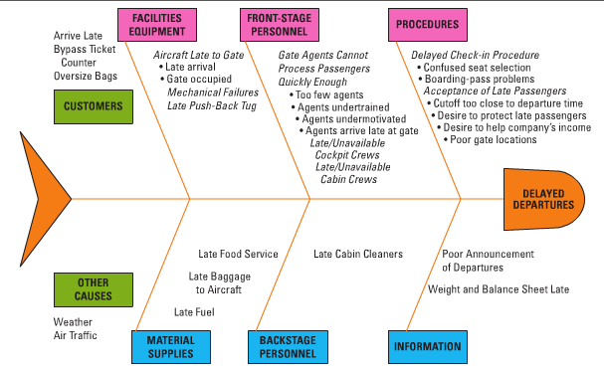
- Pareto Analysis
  - 80/20 rule
  - 80% of value of one variable, caused by 20% of casual variables
- Blueprinting
  - Identifies exact service process causing problem
  - Also identifies potential fail points, most likely to occur, how failure affects later stages of process

Return on Quality
- Assess costs and benefits of initiatives
- Determine optimal level of reliability
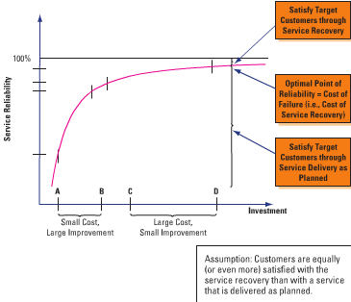

Defining and measuring productivity
Productivity - amount of output data produced relative to the amount of inputs used.
Efficiency - comparison to a standard that is usually time based
Effectiveness - degree to which an organization is meeting its goals and desired outcomes

Improving service productivity
- Generic productivity improvement strategies
  - Control costs are every step in process
  - Reduce waste of materials and labor
  - Train employees to work more productively
  - Provide equipment and databases that enable them to work faster
  - Broaden the variety of tasks that a worker can perform
  - Install expert systems.
- Customer driven approaches to improve productivity
  - Change timing of customer demand
  - Encourage use of lower cost service delivery channels and self-service
  - Ask customers to use 3rd parties

