Chapter 2: Management Past to Present

What can be learned from classical management thinking?
What ideas were introduced by the human resource approaches?
What is the role of quantitive analysis in management?
What is unique about the systems view and contingency thinking?

Classical approaches to management include:
• Scientific management
• Administrative principles
• Bureaucratic organization
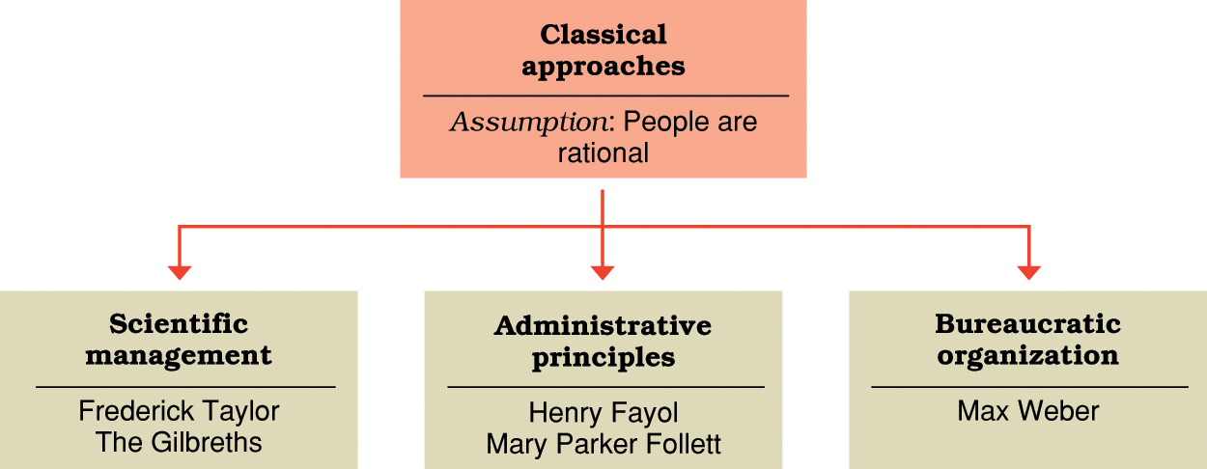

Scientific management (Fredrick Taylor)
• Develop rules of motion, standardized work implements, and proper working conditions for every job
• Carefully select workers with the right abilities for the job
• Carefully train workers and provide proper incentives
• Support workers by carefully planning their work and removing obstacles

Scientific management(The gilbreths)
- Motion study
-Science of reducing a job or task to it basic physical motions
- Eliminating wasted motions improves performance

Administrative principles (Henri Fayol)- rules of management:
- Foresight- to complete a plan of action for the future
- Organization- to provide and mobilize resources to implement the plan
- Command- to lead, selects, and evaluate workers to get the best work toward the plan
- Coordination- to fit diverse efforts together and ensure info is shared and problems solved
- Control- to make sure things happen according to plan and to take necessary corrective action

Key principles of management
-Scalar chain- there should be a clear and unbroken line of communication from the top to the bottom of the organization
- Unity of command- each person should receive orders from only one boss
- Unity of direction- one person should be in charge of all activities with the same performance objectives

Administrative principles (Mary Parker Follett)
-Groups and human cooperation:
- Groups are mechanisms through which individuals can combine their talents for a greater good.
- Organizations are cooperating “communities” of managers and workers.
- Manager’s job is to help people in the organization cooperate and achieve an integration of interests.
-Forward-looking management insights:
- Making every employee an owner creates a sense of collective responsibility (precursor of employee ownership, profit sharing, and gain-sharing)
- Business problems involve a variety of inter-related factors (precursor of systems thinking)
- Private profits relative to pubic good (precursor of managerial ethics and social responsibility)

Bureaucratic organization (Max Weber)
-Bureaucracy
- An ideal, internationally rational, and very efficient form of organization
- Based on principles of logic, order, and legitimate authority.

Characteristics of bureaucratic organizations:
- Clear division of labor
- Clear hierarchy of authority
- Formal rules and procedures
- Impersonality
- Careers based on merit
Possible disadvantages of bureaucracy:
- Excessive paperwork or “red tape”
- Slowness in handling problems
- Rigidity in the face of shifting needs
- Resistance to change
- Employee apathy

Human resource approaches include:
- Hawthorne studies
- Maslow’s theory of human needs
- McGregor’s Theory X and Theory Y
- Argyris’s theory of adult personality

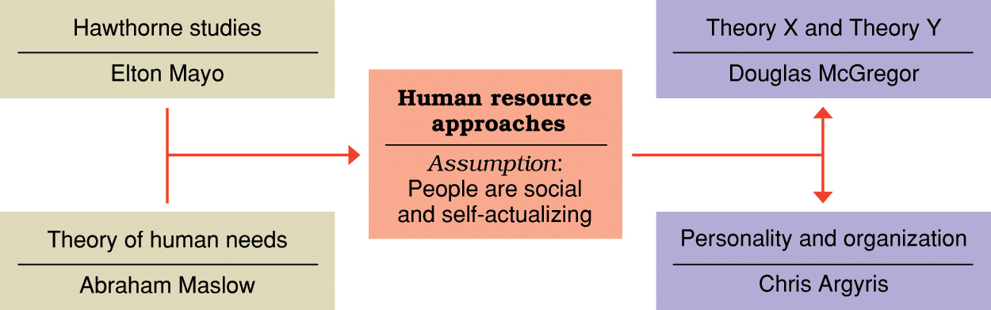

Hawthorne studies
- Initial study examined how economic incentives and physical conditions affected worker output.
- No consistent relationship found.
- “Psychological factors” influenced results.

Hawthorne studies (cont.)
  - Relay assembly test-room studies
    - Manipulated physical work conditions to assess impact on output.
    - Designed to minimize the “psychological factors” of previous experiment.
    - Factors that accounted for increased productivity:
      - Group atmosphere
      - Participative supervision

Hawthorne studies (cont.)
  - Employee attitudes, interpersonal relations, and group processes.
    - Some things satisfied some workers but not others.
    - People restricted output to adhere to group norms.
  - Lessons from the Hawthorne Studies:
    - Social and human concerns are keys to productivity.
    - Hawthorne effect — people who are singled out for special attention perform as expected.

Maslow’s theory of human needs
  - A need is a physiological or psychological deficiency a person feels compelled to satisfy.
  - Need levels:
    - Physiological
    - Safety
    - Social
    - Esteem
    - Self-actualization
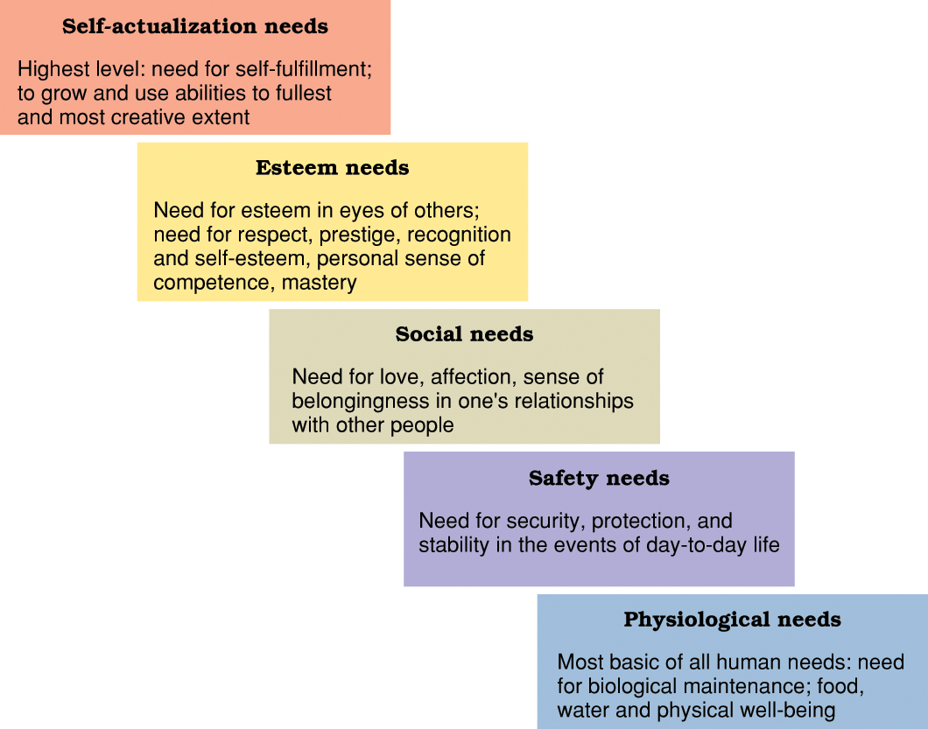

Maslow’s theory of human needs
  - Deficit principle
    - A satisfied need is not a motivator of behavior.
  - Progression principle
    - A need becomes a motivator once the preceding lower-level need is satisfied.
  - Both principles cease to operate at self-actualization level.

- McGregor’s Theory X assumes that workers:
  - Dislike work
  - Lack ambition
  - Are irresponsible
  - Resist change
  - Prefer to be led
- McGregor’s Theory Y assumes that workers are:
  - Willing to work
  - Capable of self control
  - Willing to accept responsibility
  - Imaginative and creative
  - Capable of self-direction
- Implications of Theory X and Theory Y:
  - Managers create self-fulfilling prophecies.
  - Theory X managers create situations where workers become dependent and reluctant.
  - Theory Y managers create situations where workers respond with initiative and high performance.
    - Central to notions of empowerment and self-management.
Foundations for continuing development in management:
- Quantitative analysis and tools
- Systems view of organizations
- Contingency thinking
- Commitment to quality
- Learning organizations
- Evidence-based management
Management science or operations research
- The scientific applications of mathematical techniques to management problems
- Mathematical forecasting makes future projections useful for planning
- Inventory modeling controls inventories mathematically
- Linear programming calculates how to allocate scarce resources among competing uses
- Queuing theory allocates service personnel/workstations to minimize service cost and customer waiting time
- Network models break large tasks into smaller components for better coordination.

-Operations management is the study of how organizations produce goods and services

Quality management
- ISO certification
-Global quality benchmark
-Refine and upgrade quality to meet ISO standards
- Continues improvement
-Continual search for new ways to improve quality
-Something always can and show be improved on

Knowledge Management and Organizational Learning
- Knowledge management is the process of using information technology to achieve performance success
- Portfolio of intellectual assets includes patents, intellectual property rights, trade secrets, and accumulated knowledge of the entire workforce.
Learning Organizations
- Organizations those are able to continually learn and adapt to new circumstances.
- Core ingredients include:
- Mental models
- Personal mastery
- Systems thinking
- Shared vision
- Team learning
High performance Organizations
- Organizations that consistently achieve excellence while creating a high quality work environment.
- Common characteristics of high performance organizations include:
- People oriented – value people as human assets
- Team oriented – achieve synergy through teamwork
- Information oriented – mobilizes the latest information technology
- Achievement oriented – focuses on the needs of customers and stakeholders
- Learning oriented – operates with internal culture that respects and facilitates learning

